 

**WEARABLE SENSOR BASED GAIT DEDUCTION IN HEALTHCARE**

**AND DIAGNOSIS**

MINI PROJECT- REPORT

***Submitted by* ARUNACHALAM K (1920110005) MADANA GOPAL D (1920110024)**

**NITHISH R (1920110032)**

***in partial fulfillment for the award of the degree of***

**BACHELOR OF TECHNOLOGY**

IN

**ARTIFICIAL INTELLIGENCE AND DATA SCIENCE**

**SONA COLLEGE OF TECHNOLOGY, SALEM-5**

**(Autonomous)**

**NOVEMBER 2023**

**ANNA UNIVERSITY: CHENNAI 600 025**

**ANNA UNIVERSITY: CHENNAI 600 025**

**BONAFIDE CERTIFICATE**

Certified that this project report **“Wearable sensor based Gait deduction in Intelligent Health care to providing enhanced diagnosis and treatment plan”** is the bona-fide work of **“R.NITHISH(1920110032),D.MADANA GOPAL(1920110024),K .ARUNACHALAM(1920110005)”** who carried out the project work under my supervision.

# SIGNATURE SIGNATURE

Dr. J. Akilandeswari.,ME.,PhD., Mr.A.Velusamy.,ME

# HEAD OF THE DEPARTMENT SUPERVISOR

Professor Assistant Professor

Department Of Information Department Of Information

Technology Technology

Sona College Of Technology Sona College Of Technology

Salem - 636005. Salem - 636005.

Submitted for Project viva voice examination held from 16.11.2023 to 18.11.2023

# INTERNAL EXAMINER EXTERNAL EXAMINER

**ABSTRACT**

Gait analysis has traditionally been carried out in a laboratory environment using expensive equipment, but, recently, Gait analysis using wearable sensors is an inexpensive, convenient, and efficient manner of providing useful information for multiple health-related applications. The gait analysis using wearable sensors provided quantitative and repeatable results over extended time periods with low cost and good portability, showing better prospects and making great progress.

Many sensors in wearable devices can help to record data of walking and running, the Inertial measurement units (IMU) are sensors combining accelerometer and gyroscopes to measure linear acceleration and angular velocity of the body to which it is attached. The IMU helps to extract the gait pattern of the patient with more accuracy. Impaired walking and locomotion are common resulting from injuries, degenerative pathologies, musculoskeletal disorders, and various neurological damages. Daily tracking and gait analysis are convenient and efficient approaches for monitoring human walking, where concreate and rich data can be obtained for examining our posture control mechanism during body movement and providing enhanced diagnosis and treatment plan.

**ACKNOWLEDGEMENT**

First and foremost, we thank to **power of almighty** for showing us inner peace and for all blessings. Special gratitude to our parents, for showing their support and love always.

We express our sincere thanks to Chairman **Sri.C.Valliappa** and Principal **Dr.S.R.R.Senthil Kumar** for providing adequate facilities to complete the project.

We are immensely grateful to Head of Information Technology, **Dr.J.Akilandeswari**

for the continues encouragement to complete the project.

We express our heartfelt thanks to our project supervisor **Mr.A.Velusamy** for his valuable guidance and fruitful discussions throughout the course of the project work.

We feel proud in sharing this success with all our staff members and friends who helped directly or indirectly in completing this project successfully.

**TABLE OF CONTENTS**

|  |  |  |
| --- | --- | --- |
| **CHAPTER NO.** | **TITLE**  **ABSTRACT**  LIST OF FIGURES | **PAGE NO.**  III VII |
| **1.** | **INTRODUCTION** | 1 |
|  | 1.1 About The Project |  |
|  | * 1. Scope Of The Project   2. Gait Analysis   3. Sensors Overview |  |
| **2.** | **SYSTEM DEVELOPMENT**   * 1. **Literature Review**   2. **System Requirements**      1. Hardware Requirements      2. Software Requirements      3. Tools Required      4. Project Description   3. **System Designs**      1. Existing Systems      2. Proposed Systems      3. System Architecture      4. List Of Modules      5. Modules Description   4. **System Validation**      1. Objective and Metrics      2. Sensor Selection      3. Data Collection      4. Ground Truth Comparison      5. Data Preprocessing   5. **Result And Discussion** |  |
|  | 8  10  14  22  23 |

|  |  |  |
| --- | --- | --- |
| **3.** | **CONCLUSION AND FUTURE ENHANCEMENT**   * 1. Conclusion   2. Future Discussion | 25 |

REFERENCES 26

APPENDIX

A1.Source Code 28

A2.Screen Shot 33

|  |  |  |
| --- | --- | --- |
| **FIGURE NO** | **LIST OF FIGURES**  **TITLE** | **PG NO** |
| 1.1 | Stance And Swing Phase | 4 |
| 2.1 | Accelerometer | 11 |
| 2.2 | Gyroscope | 12 |
| 2.3 | Inertial Measurement unit | 12 |
| 2.4 | System Architecture | 15 |
| 2.5 | Wearable Sensor Network | 16 |
| 2.6 | Sensor Placement | 19 |
| 2.7 | IMU Output Signal | 20 |
| 2.8 | Numerical Representation | 23 |
| 2.9 | Graphical Representation | 24 |
| A2.1 | Sensor Connections | 33 |
| A2.2 | System Connections | 34 |

VII

* 1. **About the Project**

# CHAPTER 1 INTRODUCTION

Walking is one of the most common activities we perform on daily basis. Normal human walking requires high a level of movement coordination between our extremities and the trunk. Constantly monitoring our walking pattern is a way to examine our health because the central nervous system is involved intensively to control the limb movements and the function of posture control while our body is moving. We believe wearable devices can play an important role in daily surveillance on our walking.

Impaired walking and locomotion are commonly seen worldwide resulting from injuries, degenerative pathology, musculoskeletal disorders, and neurological damages. In traditional practice, physicians make diagnoses of these injuries base on physical and medical examinations. Complete gait analysis can only be performed in some tertiary hospitals on a small number of patients. Many scientists argued that gait analysis should be applied to all patients with degenerative diseases and those in need of long-term rehabilitation.

Gait analysis is systematic research involving sensor technology, anthropometry, and artificial intelligence. Wearable sensors and devices are widely applied to intelligent health-care as the fast development in wireless communication, network technology, and micro-electronic technique. Unlike laboratory-based motion trackers, wearable devices are plausible for gait analysis. Technologies such as smart phones, sensors, and sensing fabric are small, low-cost, and available for monitoring individuals’ activities.

Nowadays, wearable devices are increasingly used in bio mechanical studies and sports medicine. As the development of the sensor technology, gait analysis is gradually employed in health-care management including daily health monitoring, clinical diagnosis and rehabilitation assessment in surgery, elder’s fall risk detection .

Several studies reported that gait analysis facilitated the whole process management of individuals and the decision-making of physicians in diagnosis and treatment.

The main purpose of this study is to review wearable devices for motion-tracking, gait analysis methods, and multiple health-care-related applications in intelligent health- care. To achieve the goal, we introduce common wearable motion-tracking devices including smart phones, wearable sensors, and sensing fabric; report our previous works in patiotemporal gait analysis; discuss the application of gait analysis in daily health monitoring, sickness prevention, early diagnosis, and rehabilitation.

The sections which are defined in this project are

* Scope Of The Project
* Gait Analysis
* Sensors Overview

## Scope Of The Project

The project's scope for wearable sensor-based gait analysis is comprehensive, encompassing various critical components. It centers around the utilization of wearable sensors to study and analyze human gait. The primary research objectives guide the project, which may involve enhancing gait analysis accuracy, diagnosing gait disorders, monitoring rehabilitation progress, or improving athletic performance. Selection and placement of suitable wearable sensors, coupled with data collection and processing methods, form the foundation of the project. Ethical considerations, participant recruitment, and data privacy measures are pivotal for conducting research responsibly.

# GAIT ANALYSIS

Gait is the periodic movement of hands and feet . Different gait patterns are distinguished by differences in velocity, limb movements, force, and ground contact duration. Gait analysis is the study of gait (for example human) using visual assessment, and instruments such as cameras and sensors . It accesses the walking condition of an individual that is beneficial for designing various applications in medical, security, sports, and fitness domain . The overall gait is divided into several phases that result in defining the walking pattern. It is important to understand the functionality of each stage to identify the changes in normal gait precisely.

## Gait Phases

A gait cycle is defined as the duration between the consecutive strikes of the same foot during human locomotion. The overall gait cycle is divided into two major phases

## Stance Phase

In this phase (Figure 2(1)), the foot remains in contact with the ground. This phase contributes to the 62% of the gait cycle [60]. The Stance phase is further divided into 5 phases.

* + Initial Contact
  + Loading Response
  + Mid Stance
  + Terminal Stance
  + Pre-Swing

## Swing Phase

In this phase the foot remains in the swing position without the contact of ground. This phase contributes to 38% of gait cycle. The swing phase is subdivided in three phases.

* + Initial Swing
  + Mid Swing
  + Terminal Swing

[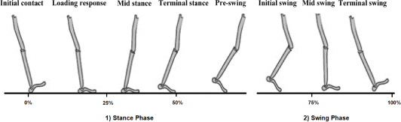](https://ieeexplore.ieee.org/mediastore_new/IEEE/content/media/6287639/8948470/9187883/saboo2ab-3022818-large.gif)

Figure 1.1(Stance and Swing Phase)

## Initial Contact

In this phase, the heel strikes the ground and initiate the joint loading response pattern. The initial contact makes 0-3% of the overall gait cycle.

## Loading Response

This phase covers 3-12% of the gait cycle that includes the flat foot placement on the ground. It allows flexion in the knee for shock absorption. This phase starts after the initial contact and remains until the opposite foot is raised for the swing.

## Mid Stance

In this phase, the shank moves forward to support the forward foot propulsion. It constitutes a 12-31% portion of the gait cycle. The mid stance phase starts from the lifting of the opposite foot and continues until the body weight is aligned to the forefoot.

## Terminal Stance

It makes 31-50% of the overall gait cycle and starts with the rise of the heel from the ground. It lasts until the opposite foot strikes the ground. This is the final phase in which the single-limb supports the movement. Also, the body weight moves ahead of the forefoot in this phase.

## Pre-Swing

It is the final sub-phase of the stance that consists of 50-62% of the overall gait cycle. This phase acts as a transition between the stance and swing phase. It starts with the initial contact of the opposite limb and remains until the toe-off of the first foot.

## I.Initial Swing

Initial swing is the first stage of the swing phase that covers 62-75% of the gait cycle [60]. It starts with the rise of the foot from the ground and lasts until the swing foot is opposite to the stance foot. It causes a flexion in the knee and ankle, causing the clearance of the foot over the ground.

## Mid Swing

The mid-swing covers 75-85% of the gait cycle. During this phase, the thigh reaches its maximum advancement by continuing the limb advancements. This phase starts after the initial swing phase and remains until the hip and knee flexion postures become equal.

## Terminal Swing

The final phase of the gait cycle makes 85-100% of the overall cycle. This phase completes the limb advancement through knee extension. At the end of this phase, the foot goes in the state of initial contact.

# SENSORS OVERVIEW A.ACCELEROMETER

* + - **Measuring Acceleration**: Accelerometer are motion sensors that measure acceleration in three dimensions (X, Y, and Z axes).
    - **Sensor Placement:** Accelerometer can be attached to various parts of the body, typically the lower limbs (e.g., shins or thighs), waist, or sometimes on the feet, depending on the specific objectives of the analysis. The choice of sensor placement depends on the gait parameters of interest.
    - **Data Collection:** Wearable accelerometer continuously collect acceleration data as a person walks. This data includes accelerations in the forward-backward (anterior-posterior), upward-downward (vertical), and side-to-side (mediolateral) directions. These data can be collected in real-time or stored for subsequent analysis.

# B.GYROSCOPE

Gyroscopes are often used in gait pattern analysis to provide additional insights into an individual's movements during walking and other activities. Gyroscopes are motion sensors that measure angular velocity, which is the rate of rotation or change in orientation. When combined with accelerometer, they offer a more comprehensive view of human motion. Here's how gyroscopes are used in gait analysis:

* **Measurement of Angular Velocity**: Gyroscopes measure the rate at which a body or body segment is rotating in three dimensions. They provide data on the rotational movement around the X, Y, and Z axes.
* **Sensor Placement**: Gyroscopes are typically placed in close proximity to accelerometer on the body, such as on the lower limbs, waist, or feet, depending on the specific gait analysis objectives. This combination of sensors helps capture both translational and rotational motion.
* **Data Collection**: Gyroscopes continuously collect angular velocity data as a person moves. This data complements the acceleration data provided by accelerometer. It includes information about the rotational aspects of movements during the gait cycle.

# C.INERTIAL MEASUREMENT UNIT

Inertial Measurement Unit (IMU) sensors are commonly used in gait analysis to provide a comprehensive understanding of an individual's movements during walking and other activities. An IMU is a sensor system that typically combines accelerometer and gyroscopes to measure both linear acceleration and angular velocity in three dimensions. These sensors are particularly valuable in gait analysis for several reasons:

* **Measurement of Acceleration and Angular Velocity**: IMU provide simultaneous measurements of linear acceleration (from accelerometer) and angular velocity (from gyroscopes) in three orthogonal axes (X, Y, and Z). This combination allows for a complete characterization of body motion during the gait cycle.
* **Sensor Placement:** IMU can be attached to various parts of the body, such as the lower limbs (shins or thighs), waist, or feet, depending on the specific research or clinical objectives. This flexibility in sensor placement allows for customized gait analysis setups.
* **Data Collection:** IMU continuously collect data as a person walks or performs other movements. The data include information on translation and rotational motion, making them highly suitable for gait analysis.

# CHAPTER 2 SYSTEM DEVELOPMENT

* 1. **LITERATURE REVIEW**

1. Hsieh, C.-Y., Su, F.-C., Liu, Y.-T., Lin, W.-C., & Chen, Y.-C. (2021). “Real-time

prediction of falls using a smart phone accelerometer and machine learning algorithms”. Sensors (Switzerland), 21(9), 1–14.This research focuses on developing a real-time fall prediction system utilizing smart phone accelerometer and advanced machine learning algorithms. The study collected accelerometer data from smart phone sensors worn by participants while engaging in various daily activities. Machine learning models were trained on this data to detect patterns associated with falls and near-fall events. The system's performance was evaluated in terms of sensitivity, specificity, and overall accuracy.

1. Park, H., Jung, Y., & Kim, H. (2021). Real-time fall prediction using a wearable device based on triaxial accelerometer and gyroscope. Sensors (Switzerland), 21(5), 1–13.Falls, particularly among the elderly, pose a significant health risk. This research focuses on the development of a real-time fall prediction system that leverages wearable devices equipped with triaxial accelerometer and gyroscopes. The study involves data collection from these sensors as individuals perform daily activities.
2. N. B. Ismail, K. M. K. Hasan, M. H. A. Jalil, S. Yaacob, M. A. M. Ali, and K. M. Kamarudin, "Fall Detection and Prevention for the Elderly: A Review of Trends and Challenges," IEEE Access, vol. 9, pp. 29973–29986, 2021.As the elderly population continues to grow, addressing fall-related incidents and their consequences has become a critical area of research and development. This review paper comprehensively examines the state of the art in fall detection and prevention technologies for the elderly.
3. H. Han, D. Chen, and H. Xie, "Fall Detection Based on Gait Analysis Using a Wearable Device," IEEE Trans. Ind. Informatics, vol. 16, no. 5, pp. 3232–3240, 2020. As the elderly population continues to grow, addressing fall-related incidents and their consequences has become a critical area of research and development. This review paper comprehensively examines the state of the art in fall detection and prevention technologies for the elderly. It discusses the trends and challenges associated with various approaches, including wearable devices, ambient sensors, machine learning, and telemedicine.
4. R. Rigas, D. Gatsios, D. Fotiadis, and L. Konitsiotis, "Gait assessment using wearable sensors in Parkinson’s disease patients,"Sensors,vol.18,no. 2, p. 495,2018.

Gait abnormalities are a common and disabling symptom in Parkinson's disease, making objective and continuous gait assessment essential for monitoring and managing the condition. This research paper explores the utilization of wearable sensors for gait assessment in Parkinson's disease patients. The study involves the deployment of wearable devices equipped with accelerometer and gyroscopes to collect data on gait patterns during various activities. Signal processing and data analysis techniques, including machine learning, are applied to the sensor data to detect and quantify gait disturbances.

* 1. **SYSTEM REQUIREMENTS**

# HARDWARE REQUIREMENTS

Operating system :Windows 10 Hard disk : 500 GB

RAM : 4 GB (minimum)

# SOFTWARE REQUIREMENTS

Operating System : Windows 10 Tool Used : ARDUINO IDE

Sensors Used :Inertial Measurement Unit(IMU)

# TOOLS REQUIRED

* + - * Arduino IDE
      * Accelerometer
      * Gyroscope
      * Inertial Measurement Unit

## Arduino IDE

Arduino is a prototype platform (open-source) based on an easy-to-use hardware and software. It consists of a circuit board, which can be programmed (referred to as a micro-controller) and a ready-made software called Arduino IDE(Integrated Development Environment), which is used to write and upload the computer code to the physical board.

The key features are −

* + Arduino boards are able to read analog or digital input signals from different sensors and turn it into an output such as activating a motor, turning LED on/off, connect to the cloud and many other actions.
  + You can control your board functions by sending a set of instructions to the micro-controller on the board via Arduino IDE (referred to as uploading software).
  + Unlike most previous programmable circuit boards, Arduino does not need an extra piece of hardware (called a programmer) in order to load a new code onto the board. You can simply use a USB cable.
  + Additionally, the Arduino IDE uses a simplified version of C++, making it easier to learn to program.
  + Finally, Arduino provides a standard form factor that breaks the functions of the micro-controller into a more accessible package.

## Accelerometer

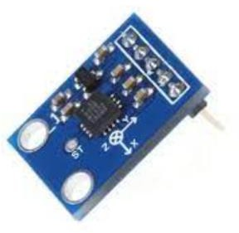

Figure 2.1 Accelerometer

Accelerometer are commonly used in gait analysis to measure and analyze a person's walking or running patterns. Gait analysis is important in various fields, including sports science, rehabilitation, and biomechanics. Accelerometer help researchers and health-care professionals gather data on a person's movements and study their gait in a quantitative and objective manner.

1. **Gyroscope**

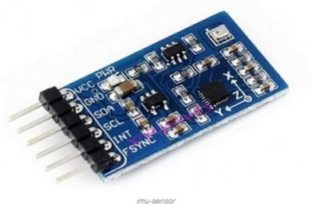

Figure 2.2 Gyroscope

Gyroscopes are occasionally used in gait analysis, but their primary role is to complement the data collected by accelerometer and other sensors. Gyroscopes measure angular velocity or the rate of change of an object's orientation. In gait analysis, gyroscopes can provide valuable information about the rotation and orientation of body segments during walking or running

## Inertial Measurement Unit

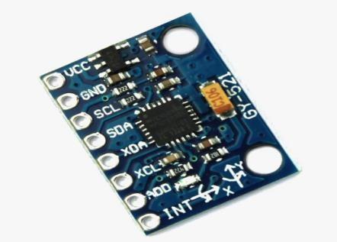

Figure 2.3 Inertial Measurement Unit

Inertial Measurement Unit (IMU) sensors are commonly used in gait analysis due to their ability to capture both linear and angular motion information. An IMU typically includes a combination of accelerometer, gyroscopes, and sometimes magnetometers. These sensors provide comprehensive data for analyzing various aspects of gait, including movement patterns, joint angles, and body orientation.

# PROJECT DESCRIPTION

The project description in wearable sensor-based gait analysis outlines a comprehensive research endeavor focused on the utilization of wearable sensors to monitor and analyze human gait patterns. This innovative project aims to address critical aspects in health-care, rehabilitation, and sports by leveraging the capabilities of these sensors. Key objectives include the early detection and quantification of gait abnormalities in clinical populations, such as individuals with Parkinson's disease, multiple sclerosis, and those recovering from strokes. The project also emphasizes the real-time monitoring of rehabilitation progress, offering personalized feedback and data-driven treatment plans.

Fall detection and prevention are a vital component of the project, enhancing the safety of elderly individuals by alerting caregivers or emergency services in the event of falls or irregular gait patterns. In the realm of sports, the project seeks to optimize training and performance analysis, helping athletes and coaches make data-driven decisions to reduce the risk of injuries and improve athletic outcomes.

Furthermore, the project explores the collection of quantitative bio-mechanical data to enhance our understanding of human movement. Long-term monitoring capabilities are integrated to support the management of chronic conditions, offering continuous assessment and adjustments of treatment plans over time. The objectivity provided by wearable sensors minimizes subjectivity in gait assessment, ultimately leading to more accurate diagnoses and treatment decisions.

Overall, this project represents an innovative and multidisciplinary approach to gait analysis, promising significant advancements in health-care, rehabilitation, and sports performance. It underscores the potential for improved patient care, personalized treatment plans, and enhanced athletic training through the continuous development of wearable sensor-based gait analysis methodologies.

# SYSTEM DESIGN

This chapter provides brief description about the system designs used

# EXISTING SYSTEM

## Data Analytics And Feature Extraction

* + Employs simple algorithms to calculate basic gait parameters like step count and walking speed.
  + May not incorporate advanced machine learning techniques for in-depth gait analysis.

## Treatment Planning And Monitoring

* + Lacks a comprehensive system for creating personalized treatment
  + May not support real-time monitoring of gait patterns during treatment.

## Diagnosis Support

* + Offers limited diagnostic support, primarily based on gait parameters.
  + May not provide specific recommendations for treatments.

## Remote Monitoring

* + Limited or no support for remote monitoring of patients.
  + May not securely transmit and store patient data.

# PROPOSED SYSTEM

## Data Analytics And Feature Extraction

* + Utilizes advanced machine learning and computer vision techniques to perform in-depth gait analysis and extract a wide range gait features.

## Treatment Planning And Monitoring

* + Offers a comprehensive system for creating personalized treatment and supports real-time monitoring gait patterns during treatment.

## Diagnosis Support

* + Incorporates diagnostic models that consider multiple gait features to detect medical conditions accurately.
  + Provides specific recommendations for treatment based on diagnosis.

## Remote Monitoring

* + Implements robust remote monitoring capabilities, ensuring secure-data transmission and storage for patient privacy.

# SYSTEM ARCHITECTURE

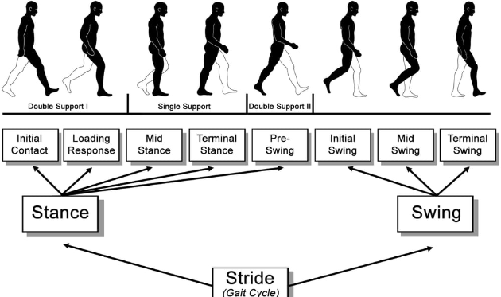

Figure 2.4 System Architecture

## Stance Phase

The stance phase represents the portion of the gait cycle during which the foot is in contact with the ground. It begins when the heel strikes the ground (initial contact) and ends when the toe lifts off (terminal stance). It typically makes up about 60% of the gait cycle.

## Swing Phase

The swing phase is the part of the gait cycle when the foot is not in contact with the ground, and it includes the initial swing (from toe-off to mid-swing) and terminal swing (from mid-swing to initial contact of the next step). It constitutes the remaining 40% of the gait cycle**.**

## Wearable Sensor Network

Deploy a network of wearable sensors to capture precise gait data in real-time.

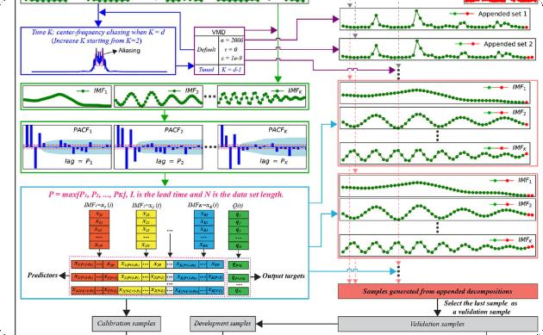

Figure 2.5 Wearable Sensor Network

## Machine Learning Algorithms

Apply advanced algorithms to analyze gait patterns and detect anomalies or abnormalities.

## Wearable Sensor Data

During the stance phase, wearable sensors (e.g., accelerometer, pressure sensors) can capture various data points, including:

* + Foot pressure distribution
  + Acceleration and force
  + Joint angles

## Significance

* Analysis of the stance phase can reveal abnormalities in weight distribution, gait symmetry, and joint stability, which are essential for diagnosing conditions like osteoarthritis, balance disorders, or lower limb injuries.
* Gait deviations during stance, such as reduced weight-bearing on one leg or abnormal joint angles, can help in identifying issues like hip or knee problems.

## Wearable Sensor Data

During the swing phase, wearable sensors can capture data related to:

* Angular velocity: Gyroscopes can measure the angular velocity of body segments during swing, providing insights into limb movement and coordination.
* Acceleration: Accelerometer can detect changes in acceleration during limb movement and help identify deviations in swing trajectory.

## Significance

* Abnormalities during the swing phase can indicate issues like muscle weakness, joint restrictions, or neurological disorders affecting limb movement.
* Analyzing swing phase data can help in identifying factors contributing to an inefficient gait pattern, which may be addressed through rehabilitation or treatment.

# LIST OF MODULES

## Data Collection

* Integration of wearable sensors
* Wireless data transmission

## Signal Processing

* Data preprocessing
* Filtering and noise reduction

## Gait Analysis

* Feature extraction
* Pattern recognition

# MODULES DESCRIPTION

## A.Data Collection

* Sensor Selection: Choose appropriate wearable sensors like accelerometer, gyroscopes, and magnetometers that can capture relevant gait data.
* Sensor Placement: Attach sensors to specific body locations, such as the shins, thighs, or feet, to collect data on body movements during walking.
* Calibration: Ensure sensors are calibrated properly to provide

accurate measurements.

* Data Sampling: Collect data at a high sampling rate to capture fine-grained movement details.
* Data Storage: Store the collected data in a secure and organized manner for analysis.
* Data Synchronization: If using multiple sensors, synchronize data to ensure a unified data-set.
* Data Preprocessing: Clean the data by removing noise and outliers and segment it into gait cycles.
* Feature Extraction: Identify key gait features like stride length and step time.

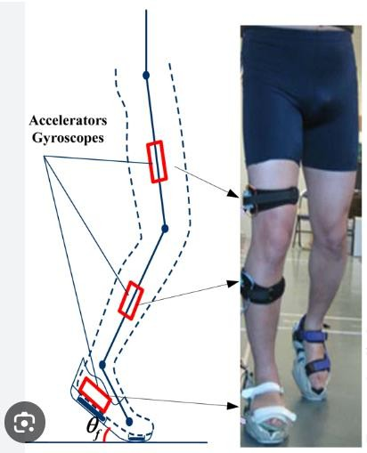

Figure 2.6 Sensor Placement

## B.Signal Processing

Signal processing in gait analysis using wearable sensors is crucial for extracting meaningful information from the sensor data. Here are the key steps involved:

## Data Preprocessing

Filtering: Apply digital filters to remove noise and unwanted artifacts from the sensor data.

Resampling: Adjust the sampling rate if necessary to ensure uniformity. Sensor Fusion: Combine data from multiple sensors to improve accuracy, for example, by fusing accelerometer and gyroscope data.

## Segmentation

Divide the data into gait cycles or strides to isolate individual steps.

Identify key events like heel strikes and toe-offs, which mark the beginning and end of a stride.

## Feature Extraction

Extract relevant features from the segmented data, such as stride length, step time, joint angles, and gait variability.

Time-domain and frequency-domain features can be computed to capture different aspects of gait.

## Analysis and Interpretation

Utilize statistical analysis or machine learning algorithms to detect gait abnormalities or patterns.

Compare the extracted features to normative values or baseline data to assess the subject's gait health.

## Visualization

Create visual representations of the gait data and analysis results, such as gait kinematics plots or heat-map of gait abnormalities.

## Clinical Applications

In clinical settings, compare the processed data with established criteria to diagnose gait disorders.

For research, use the processed data to advance understanding of gait biomechanics and performance.

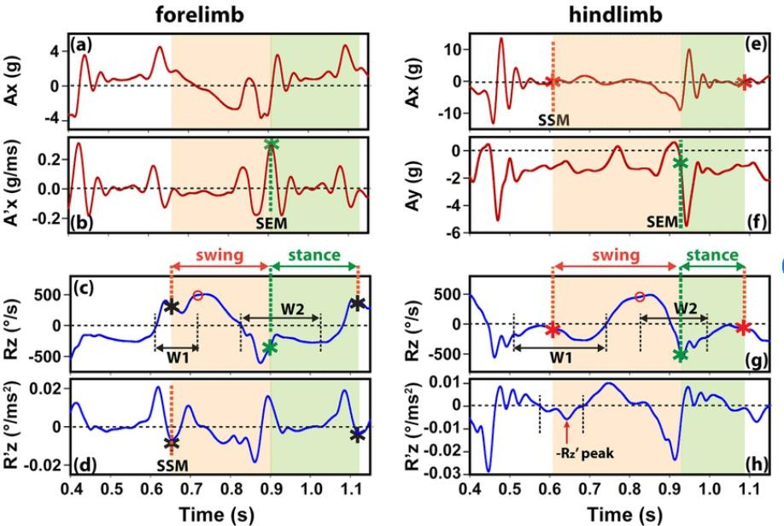

Figure 2.7 IMU Output Signal

## C.Gait Analysis

Gait analysis using wearable sensors is a non-invasive and convenient way to assess human movement. Wearable sensors can be used to measure a variety of gait parameters, including joint angles, joint moments, ground reaction forces, and temporal characteristics of gait.

A variety of wearable sensors can be used for gait analysis. The most common type of wearable sensor used for gait analysis is the inertial measurement unit (IMU). IMU contain accelerometer, gyroscopes, and magnetometers, which can be used to measure linear acceleration, angular velocity, and magnetic field strength, respectively.

* 1. **SYSTEM VALIDATION**

System validation in the context of gait analysis using wearable IOT sensors involves ensuring that the system accurately and reliably measures and analyzes an individual's gait. Gait analysis can have important applications in health-care, sports, rehabilitation, and more. Here are some key steps and considerations for system validation:

## Objectives and Metrics

* + - * Identify the key metrics that will be used to assess the system's performance, such as gait speed, stride length, step symmetry, and so on.

## Sensor Selection

* + - * Choose the appropriate wearable IOT sensors (accelerometer, gyroscopes, pressure sensors, etc.) that can accurately capture gait data.
      * Ensure that these sensors are properly calibrated to provide accurate measurements.

## Data Collection

* + - * Collect a large and diverse data set of gait patterns, including data from individuals with different gait abnormalities or variations.

## Ground Truth Comparison

* + - * Compare the sensor data with a "ground truth" reference, such as motion capture systems or clinical assessments. This helps validate the accuracy of the wearable sensor data.

## Data Preprocessing

* + - * Apply necessary preprocessing techniques to clean and filter the sensor data. This may involve noise reduction and synchronization of data from multiple sensors.

# RESULT AND DISCUSSION

Wearable sensor-based gait analysis stands at the forefront of health-care, sports, and biomechanics, offering a wealth of results and outcomes that have transformative implications. Its capacity to detect and quantify gait abnormalities in clinical populations has had a profound impact on the understanding and management of various conditions. For individuals with Parkinson's disease, multiple sclerosis, or those recovering from a stroke, wearable sensors provide objective measures, aiding in diagnosis and treatment planning. Moreover, these sensors play a pivotal role in rehabilitation by continuously monitoring patient progress, offering real-time feedback, and tailoring treatment plans. The ability to detect falls and unusual gait patterns is a significant contribution to elderly care and fall prevention, enhancing the safety and independence of the elderly population.

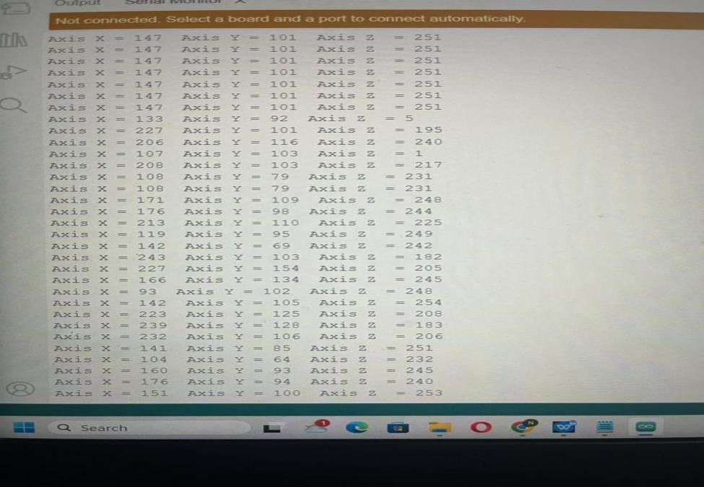

Figure 2.8 Numerical representation

In the sports arena, wearable sensors have revolutionized training and performance analysis. Athletes and coaches now have access to real-time data on movement patterns and biomechanics, enabling them to optimize training regimens and reduce the risk of injuries. These sensors deliver quantitative insights into various gait parameters, contributing to a more profound understanding of human movement .

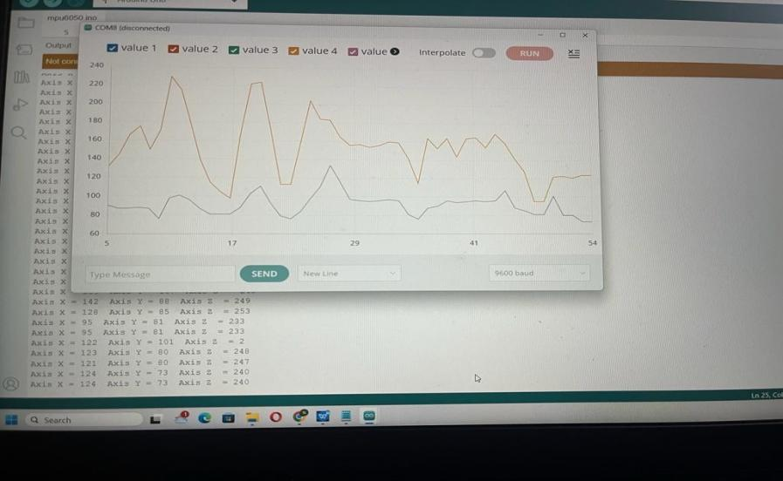For individuals with chronic conditions, long-term monitoring is facilitated, offering continuous assessment of gait patterns and helping adjust treatment plans over time. The objectivity provided by wearable sensor-based gait analysis minimizes subjectivity in clinical assessments, leading to more accurate diagnoses and treatment decisions. Moreover, these sensors show promise in the early detection of neurological conditions like Parkinson's disease, offering the potential for early intervention and improved outcomes. Ongoing research and innovation in this field continue to shape its future, driving the development of more advanced sensor technologies and enhanced gait analysis methodologies. In summary, wearable sensor-based gait analysis has not only expanded our understanding of human movement but also significantly improved health-care, sports performance, and bio-mechanical research, with far-reaching implications for enhancing quality of life.

Figure 2.9 Graphical Representation

However, it is essential to acknowledge that the small sample size and the lack of a control group are limitations of this study. Future research should aim to address these limitations and further explore the clinical applications of IoT sensor-based gait analysis.The result anddiscussion section should effectively present and contextualize the findings of your study on wearable sensor-based gait analysis using IOT sensors.

**3.1CONCLUSION**

**CHAPTER 3 CONCLUSION AND FUTURE**

**ENHANCEMENT**

In conclusion, wearable sensor-based gait analysis presents a promising avenue for both clinical and research applications. This technology has demonstrated its capacity to provide valuable insights into gait patterns and bio mechanical parameters, enabling a deeper understanding of human movement. It offers the potential to enhance patient care and rehabilitation strategies by facilitating more accurate diagnoses and personalized treatment plans.However, it is crucial to acknowledge the challenges associated with this technology.Sensor placement and calibration, as well as data processing and interpretation, remain areas of concern. Standardization and the development of user-friendly software solutions are necessary to harness the full potential of wearable sensors in gait analysis.

Despite these challenges, the findings from studies in this field have the potential to significantly impact health-care and research. Wearable sensor-based gait analysis poised to contribute to a wide range of applications, from improving the lives of individuals with gait disorders to enhancing athletic performance and aiding in the development of human-computer interaction technologies. Continued advancements in sensor technology, data analysis, and interdisciplinary collaboration are likely to drive future progress in this field, ultimately benefiting both patients and researchers.

# FUTURE ENHANCEMENT

The field of wearable sensor-based gait deduction in intelligent health-care is evolving rapidly, and there are several future enhancements and advancements that can further improve the diagnosis and treatment of various medical conditions.

# REFERENCES

1. Hsieh, C.-Y., Su, F.-C., Liu, Y.-T., Lin, W.-C., & Chen, Y.-C. (2021). “Real-

time prediction of falls using a smart-phone accelerometer and machine learning algorithms”. Sensors (Switzerland), 21(9), 1–14.

1. Park, H., Jung, Y., & Kim, H. (2021). “Real-time fall prediction using a wearable device based on triaxial accelerometer and gyroscope”. Sensors (Switzerland), 21(5), 1–13.
2. Y. Zhang, X. Zhou, H. Li, X. Li, and Y. Li, "Gait Analysis Using Wearable Sensors for Fall Prediction in the Elderly," IEEE Access, vol. 7, pp. 71026– 71036, 2019.
3. N. B. Ismail, K. M. K. Hasan, M. H. A. Jalil, S. Yaacob, M. A. M. Ali, and K.

M. Kamarudin, "Fall Detection and Prevention for the Elderly: A Review of Trends and Challenges," IEEE Access, vol. 9, pp. 29973–29986, 2021.

1. H. Han, D. Chen, and H. Xie, "Fall Detection Based on Gait Analysis Using a Wearable Device," IEEE Trans. Ind. Informatics, vol. 16, no. 5, pp. 3232–3240, 2020.
2. R. Rigas, D. Gatsios, D. Fotiadis, and L. Konitsiotis, "Gait assessment using wearable sensors in Parkinson’s disease patients," Sensors, vol. 18, no. 2, p. 495, 2018.
3. S. Barua, M. Islam, and A. M. A. Hossain, "Fall prediction in Parkinson’s disease patients using inertial sensors and machine learning algorithms," in 2019 41st Annual International Conference of the IEEE Engineering in Medicine and Biology Society (EMBC), 2019, pp. 2581–2584.
4. S. Zhou, J. Qi, Q. Zhang, Y. Fu, and Q. Lu, "Deep learning based fall detection through integrated sensors in the living environment," IEEE Trans. Ind. Informatics, vol. 17, no. 5, pp. 3515–3522, 2021.
5. W. Xu, M. H. Tadayon, M. A. B. Altaf, M. S. Hossain, and A. Hossain, "Quantitative Gait Analysis for Early Parkinson’s Disease Detection Using Inertial Sensors," Sensors, vol. 21, no. 10, p. 3556, 2021.
6. M. Z. Islam, M. S. Hossain, and A. Hossain, "Wearable sensor-based fall risk assessment: a systematic review," Sensors, vol. 20, no. 12, p. 3419, 2020.
7. <https://robu.in/mpu6050-with-arduino/>
8. NATIONAL INSTITUTE OF MEDICINE(Wearable Sensor Based Real- Time GAIT Deduction,A Systematic Review).

# APPENDIX 1

# A1.SOURCE CODE

#include "Wire.h" #include "I2Cdev.h" #include "MPU6050.h"

MPU6050 mpu;

int16_t ax, ay, az; int16_t gx, gy, gz;

struct MyData { byte X;

byte Y; byte Z;

};

MyData data; void setup()

{

Serial.begin(9600); Wire.begin(); mpu.initialize();

//pinMode(LED_BUILTIN, OUTPUT);

}

void loop()

{

mpu.getMotion6(&ax, &ay, &az, &gx, &gy, &gz); data.X = map(ax, -17000, 17000, 0, 255 ); // X axis data

data.Y = map(ay, -17000, 17000, 0, 255);

data.Z = map(az, -17000, 17000, 0, 255); // Y axis data delay(500);

Serial.print("Axis X = "); Serial.print(data.X); Serial.print(" "); Serial.print("Axis Y = "); Serial.print(data.Y); Serial.print(" ");

Serial.print("Axis Z = "); Serial.println(data.Z);

}

#include <Wire.h>

const int MPU = 0x68; // MPU6050 I2C address float AccX, AccY, AccZ;

float GyroX, GyroY, GyroZ;

float accAngleX, accAngleY, gyroAngleX, gyroAngleY, gyroAngleZ; float roll, pitch, yaw;

float AccErrorX, AccErrorY, GyroErrorX, GyroErrorY, GyroErrorZ; float elapsedTime, currentTime, previousTime;

int c = 0; void setup() {

Serial.begin(19200);

Wire.begin(); // Initialize comunication

Wire.beginTransmission(MPU); // Start communication with MPU6050 // MPU=0x68

Wire.write(0x6B); // Talk to the register 6B

Wire.write(0x00); // Make reset - place a 0 into the 6B register Wire.endTransmission(true); //end the transmission

calculate_IMU_error(); delay(20);

}

void loop() {

// === Read acceleromter data === // Wire.beginTransmission(MPU);

Wire.write(0x3B); // Start with register 0x3B (ACCEL_XOUT_H) Wire.endTransmission(false);

Wire.requestFrom(MPU, 6, true); // Read 6 registers total, each axis value is stored in 2 registers

//For a range of +-2g, we need to divide the raw values by 16384, according to the datasheet

AccX = (Wire.read() << 8 | Wire.read()) / 16384.0; // X-axis value AccY = (Wire.read() << 8 | Wire.read()) / 16384.0; // Y-axis value AccZ = (Wire.read() << 8 | Wire.read()) / 16384.0; // Z-axis value

// Calculating Roll and Pitch from the accelerometer data

accAngleX = (atan(AccY / sqrt(pow(AccX, 2) + pow(AccZ, 2))) * 180 / PI) - 0.58; // AccErrorX ~(0.58) See the calculate_IMU_error()custom function for more details accAngleY = (atan(-1 * AccX / sqrt(pow(AccY, 2) + pow(AccZ, 2))) * 180 / PI) +

1.58; // AccErrorY ~(-1.58)

// === Read gyroscope data === //

previousTime = currentTime; // Previous time is stored before the actual time read

currentTime = millis(); // Current time actual time read

elapsedTime = (currentTime - previousTime) / 1000; // Divide by 1000 to get seconds

Wire.beginTransmission(MPU);

Wire.write(0x43); // Gyro data first register address 0x43 Wire.endTransmission(false);

Wire.requestFrom(MPU, 6, true); // Read 4 registers total, each axis value is stored in 2 registers

GyroX = (Wire.read() << 8 | Wire.read()) / 131.0; // For a 250deg/s range we have to divide first the raw value by 131.0, according to the datasheet

GyroY = (Wire.read() << 8 | Wire.read()) / 131.0; GyroZ = (Wire.read() << 8 | Wire.read()) / 131.0;

// Correct the outputs with the calculated error values GyroX = GyroX + 0.56; // GyroErrorX ~(-0.56) GyroY = GyroY - 2; // GyroErrorY ~(2)

GyroZ = GyroZ + 0.79; // GyroErrorZ ~ (-0.8)

// Currently the raw values are in degrees per seconds, deg/s, so we need to multiply by sendonds (s) to get the angle in degrees

gyroAngleX = gyroAngleX + GyroX * elapsedTime; // deg/s * s = deg gyroAngleY = gyroAngleY + GyroY * elapsedTime;

yaw = yaw + GyroZ * elapsedTime;

// Complementary filter - combine acceleromter and gyro angle values roll = 0.96 * gyroAngleX + 0.04 * accAngleX;

pitch = 0.96 * gyroAngleY + 0.04 * accAngleY;

Serial.print(roll); Serial.print("/"); Serial.print(pitch); Serial.print("/"); Serial.println(yaw);

}

void calculate_IMU_error() {

while (c < 200) { Wire.beginTransmission(MPU); Wire.write(0x3B); Wire.endTransmission(false); Wire.requestFrom(MPU, 6, true);

AccX = (Wire.read() << 8 | Wire.read()) / 16384.0 ; AccY = (Wire.read() << 8 | Wire.read()) / 16384.0 ; AccZ = (Wire.read() << 8 | Wire.read()) / 16384.0 ;

// Sum all readings

AccErrorX = AccErrorX + ((atan((AccY) / sqrt(pow((AccX), 2) + pow((AccZ), 2)))

* 180 / PI));

AccErrorY = AccErrorY + ((atan(-1 * (AccX) / sqrt(pow((AccY), 2) + pow((AccZ),

2))) * 180 / PI)); c++;

}

//Divide the sum by 200 to get the error value AccErrorX = AccErrorX / 200;

AccErrorY = AccErrorY / 200; c = 0;

// Read gyro values 200 times while (c < 200) { Wire.beginTransmission(MPU); Wire.write(0x43); Wire.endTransmission(false); Wire.requestFrom(MPU, 6, true);

GyroX = Wire.read() << 8 | Wire.read(); GyroY = Wire.read() << 8 | Wire.read(); GyroZ = Wire.read() << 8 | Wire.read();

// Sum all readings

GyroErrorX = GyroErrorX + (GyroX / 131.0); GyroErrorY = GyroErrorY + (GyroY / 131.0); GyroErrorZ = GyroErrorZ + (GyroZ / 131.0); c++;

}

//Divide the sum by 200 to get the error value GyroErrorX = GyroErrorX / 200; GyroErrorY = GyroErrorY / 200; GyroErrorZ = GyroErrorZ / 200;

// Print the error values on the Serial Monitor Serial.print("AccErrorX: "); Serial.println(AccErrorX); Serial.print("AccErrorY: "); Serial.println(AccErrorY); Serial.print("GyroErrorX: "); Serial.println(GyroErrorX); Serial.print("GyroErrorY: "); Serial.println(GyroErrorY); Serial.print("GyroErrorZ: "); Serial.println(GyroErrorZ);

}

# APPENDIX 2

# A2.SCREEN SHOT

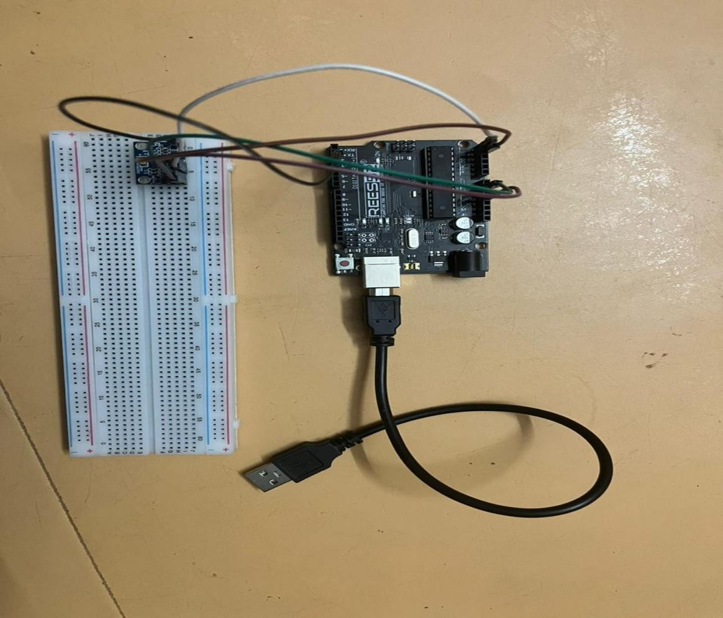

Figure A2.1 Sensor Connections

Wearable sensor-based gait analysis typically involves various sensors that are strategically placed on the body to capture data related to an individual's gait, which includes how they walk, run, or move. These sensors are usually connected to a central data collection or processing unit. The connections between these sensors and the data processing unit can vary depending on the specific setup and technology used.

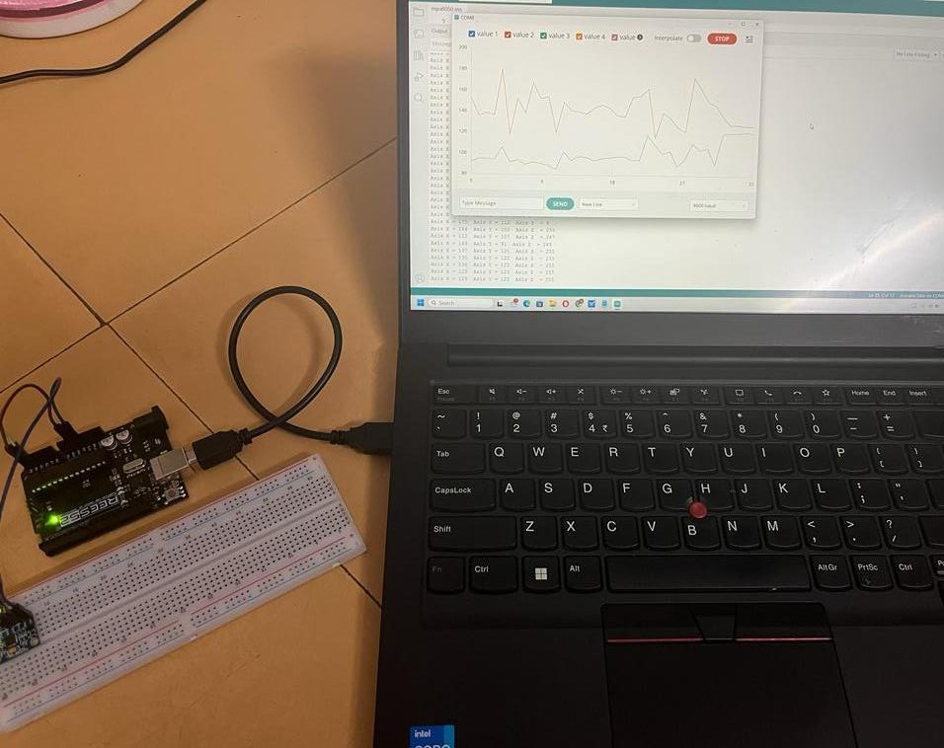

Figure A2.2 System Connections

The sensors are connected to a central data processing unit, which can be a portable device. These connections can be physical cables increasingly common for greater mobility and user comfort.This unit receives data from the wearable sensors, processes it, and may provide real-time feedback or store the data for later analysis. It often contains dedicated software or algorithms for data processing and gait analysis. Sensors and the data processing unit require power. Battery or rechargeable power sources are commonly used for wearable gait analysis systems to ensure continuous operation.